
Memorial Glen Property Owner’s Association
New Construction and Remodel Approval Request Form
Please fill in the blanks and re-save this file as: “MGPO Approval Request_Your Property Address.doc”
Applicant: Click here to enter text. Date: Click here to enter text.
Property Owner: Click here to enter text.
Property Address: Click here to enter text.
Mailing Address: Click here to enter text.
Phone: Click here to enter text. Email: Click here to enter text.
Architect: Click here to enter text.
Phone: Click here to enter text. Email: Click here to enter text.
Contractor: Click here to enter text.
Phone: Click here to enter text. Email: Click here to enter text.
Project Information and Proposed Design

Please check one:
New Construction ☐ Exterior Remodel or Change to Footprint ☐

Please fill in what is applicable for your project below:
Front Setback: Click here to enter text. Rear: Click here to enter text.
East Side: Click here to enter text. West Side: Click here to enter text.
Stories: Click here to enter text. Building Height Above F.F.: Click here to enter text.
F.F. Above Grade: Click here to enter text. Combined Total Height: Click here to enter text.
Façade Material Design
(Required Information for New Construction and Exterior Remodels/Changes to Footprint)

Total Area of Façade (A): Click here to enter text. SF
Total Area of Windows/Doors/Openings(B): Click here to enter text. SF
Total Area of Masonry(C): Click here to enter text. SF
(C) / (A-B) = Click here to enter text. x100 = Click here to enter text. Masonry Percentage
(See Example Façade Percentage Calculation Methodology – following page)
Memorial Glen Property Owner’s Association
New Construction and Remodel Approval Request Form

Example Façade Percentage Calculation Methodology
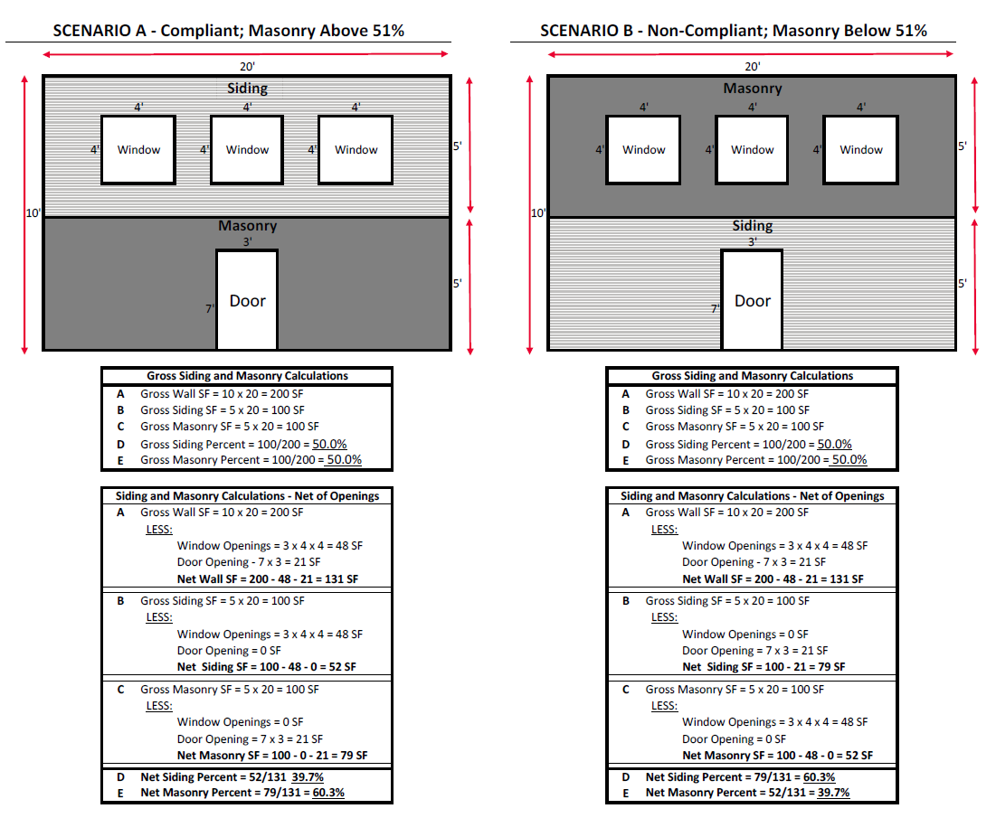
Memorial Glen Property Owner’s Association
New Construction and Remodel Approval Request Form
Architectural Review Committee (“ARC”) Plan Review Fees

Non‐Refundable, Plan Review Fees – Please submit your Plan Review Fee along with the Approval Request Form and a copy of your plans. Drawings will be reviewed by a third‐party Architect and the MGPO ARC, with final approval required by the MGPO Board of Directors before construction may proceed.

☐ $1,250.00 New Home Construction
☐ $850.00 Exterior Remodel or Changes to Footprint

Please make checks payable to MGPO, note the property address in the subject line and mail to:

Memorial Glen POA
12818 Willow Centre Ste B
Houston Tx 77066

Owners Acknowledgement
I understand:
That no work on this request shall commence until I have received written approval from the Memorial Glen Property Owner’s Association Board. Any construction or alteration to my property prior to approval of the Board is strictly prohibited.
All proposed improvements to the property must comply with City, County, State and Local Codes. No fill dirt allowed. Any dirt from construction activities that raises the elevation of the existing grade to be removed promptly from the site. I understand that applications for all required building permits are my responsibility.

That any variation from the original application must be resubmitted for approval.
The Builder/Applicant agrees to grant the Board and its agents accesses to the property at any reasonable hour to inspect for compliance issues.

I certify that the above information is an accurate representation of the proposed improvements and that the work will conform to applicable codes, covenants and standards. I also certify that the improvements will be completed in accordance with the approved application.
Property Owner_______________________________________________Date:_________________
Signature

PLEASE DO NOT SUBMIT HARD COPIES of your plans nor this Submittal form. Please send SCAN COPIES to this email address: MemorialGlen1@gmail.com

